Task 1: Created infra using terraform. VPC, private subnets-2, public subnets-2, IGW, NAT. And security groups. ALB for accessing Jenkins in private subnet.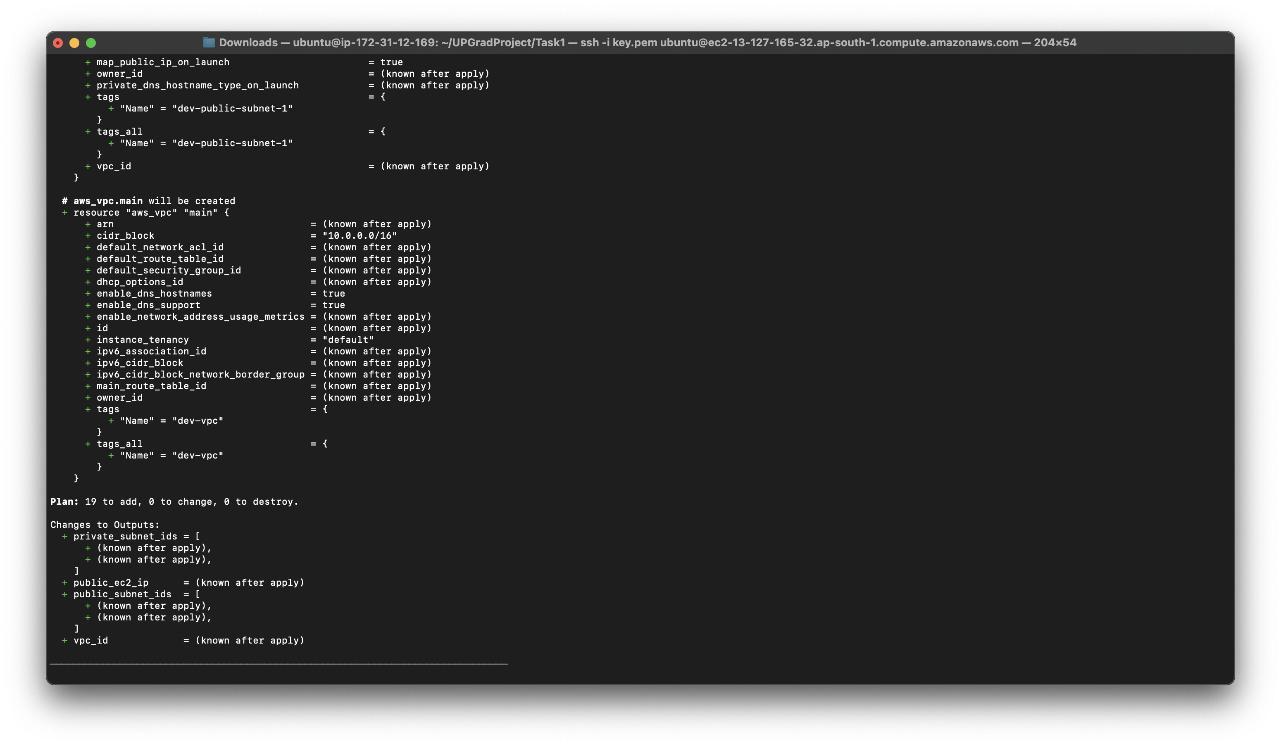

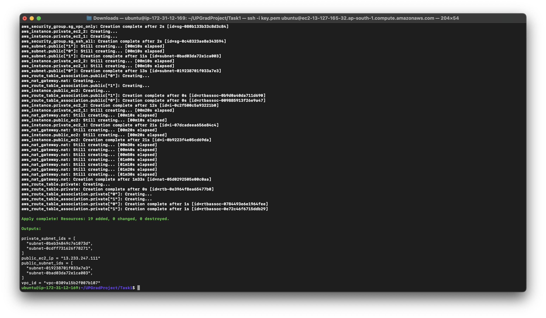

Console output for infra:

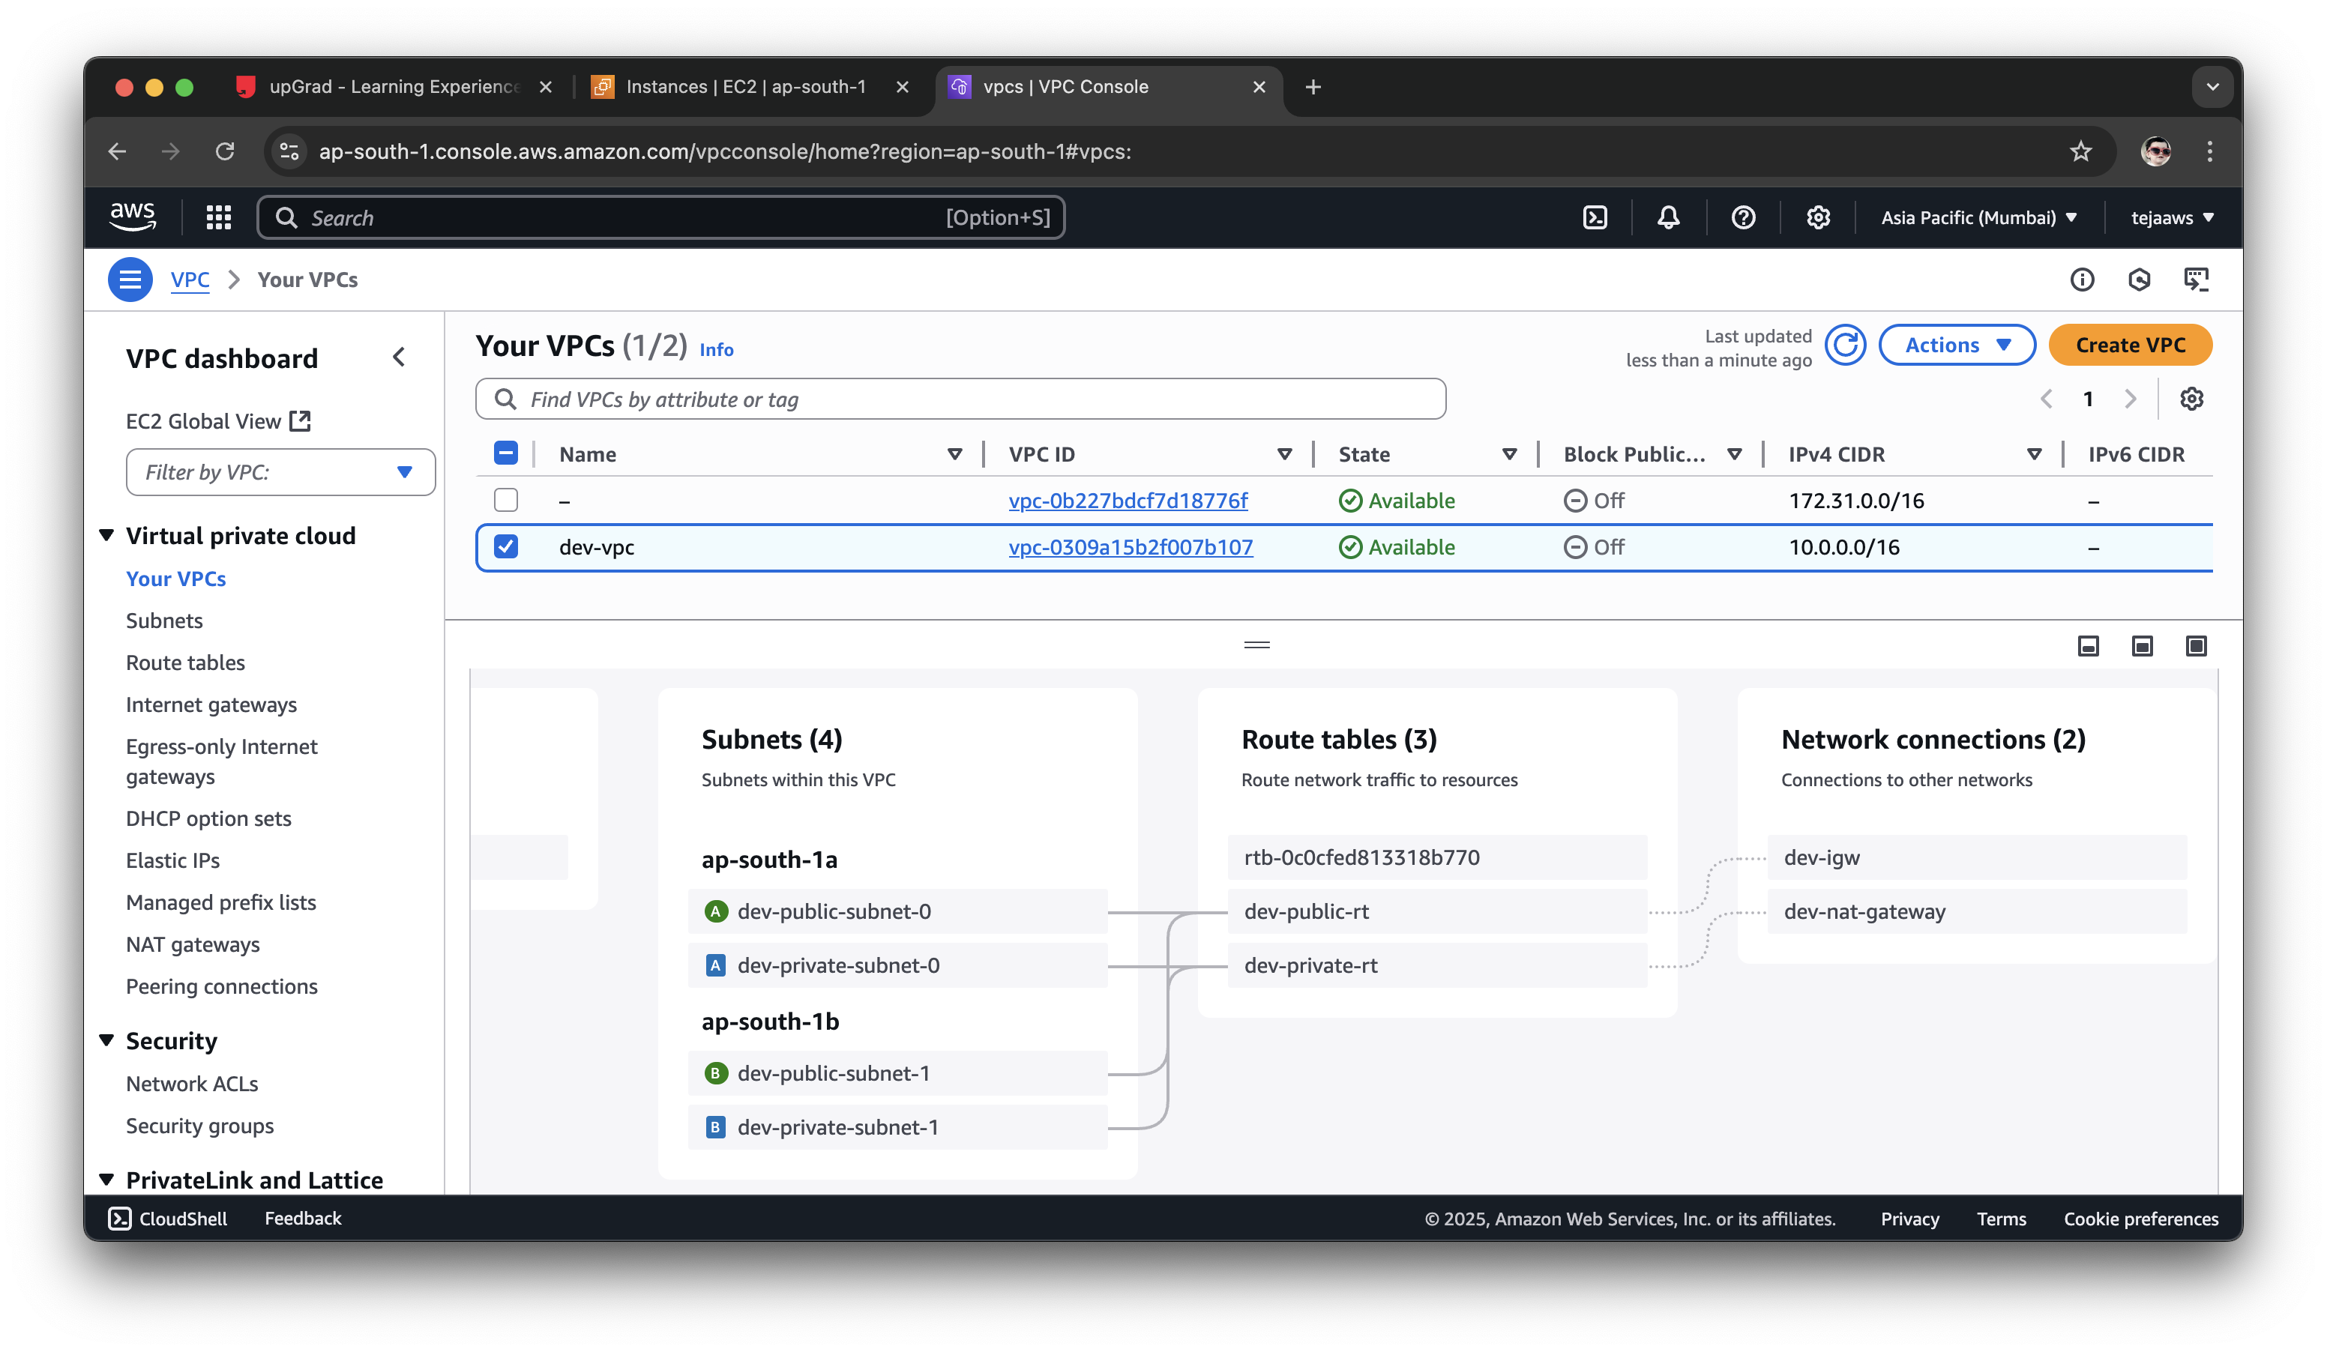

Task2: Installing Docker in Jenkins and APP servers through ansible. Ansible installed manually  
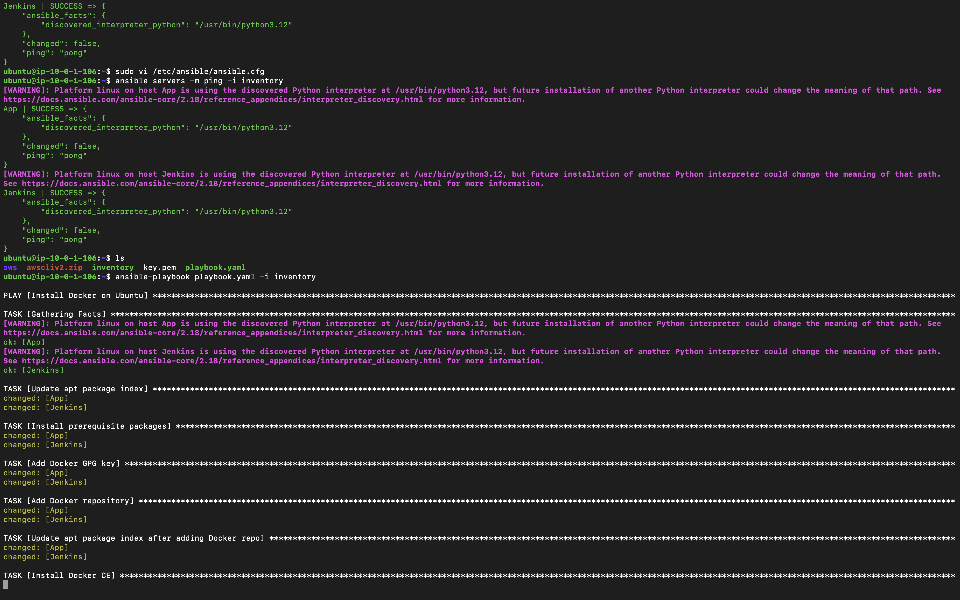

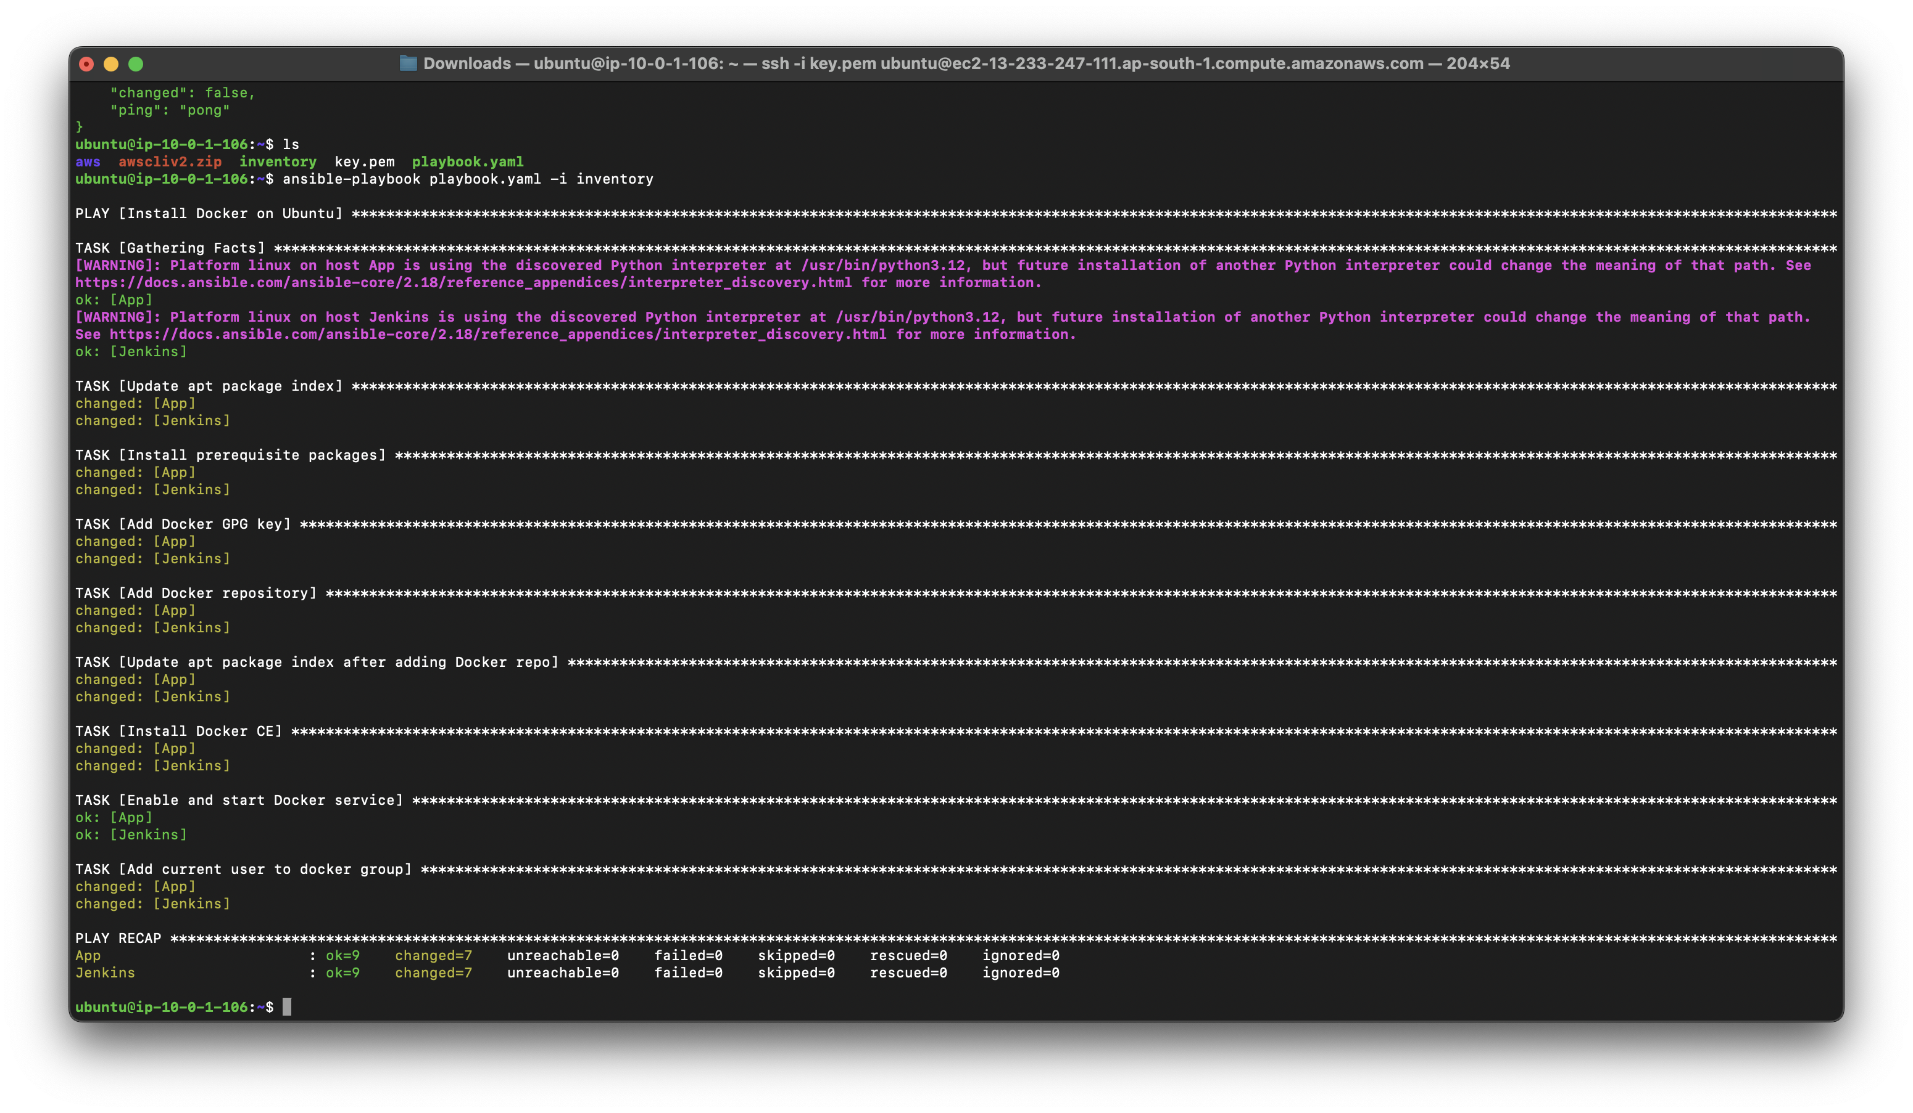

Installed Jenkins as docker container and accessible through ALB manually by logging into Jenkins server



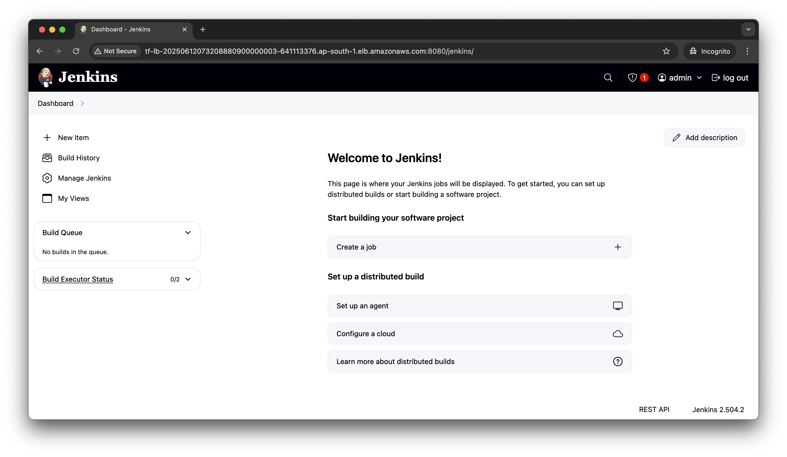

Task3: Deploying vote app in private ec2 and accessing using alb

App code kept in private repo: https://github.com/Teja2803/upgrad-app.git'

Added Jenkins file and added GitHub credentials, was iam role in Jenkins config and sshkey

Build got success  
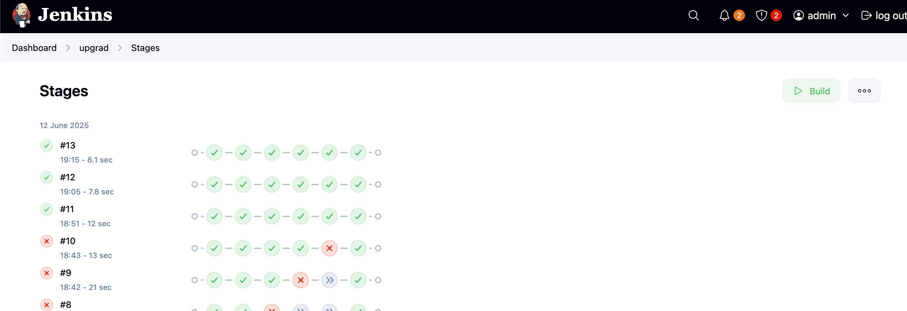

Checked output:

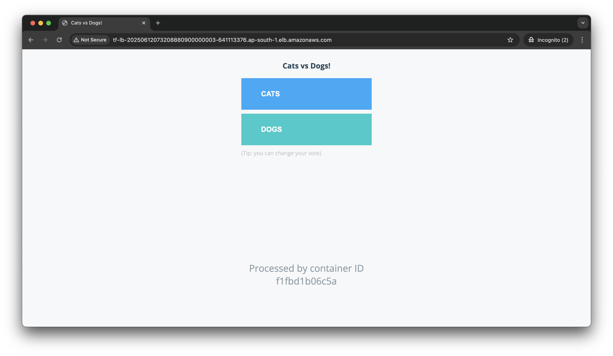

Github link for all tasks: https://github.com/Teja2803/UPGradProject.git